# Experience

[Company Name](https://www.linkedin.com/company/1217/)

[Vodafone](https://www.linkedin.com/company/1217/)

[Dates EmployedNov 2018 – Present](https://www.linkedin.com/company/1217/)

[Employment Duration10 mos](https://www.linkedin.com/company/1217/)

[LocationLondon, United Kingdom](https://www.linkedin.com/company/1217/)

### [Leo Tech Consulting Ltd.](https://www.linkedin.com/search/results/index/?keywords=Leo%20Tech%20Consulting%20Ltd.)

#### [Total Duration2 yrs 4 mos](https://www.linkedin.com/search/results/index/?keywords=Leo%20Tech%20Consulting%20Ltd.)

### TitleScrum Master

#### Dates EmployedJun 2017 – Jul 2018

#### Employment Duration1 yr 2 mos

#### LocationLondon, United Kingdom

As a Scrum Master for a productive agile team, my role is to ensure continuous improvement across the development team through effective facilitation. Based on the input from team members, I helped set up an inspiring agile environment that fosters collaboration and group discussion. Together with the development team, we identify impediments and attempt to remove or mitigate these blockages. Encouraging close cooperation between the Product Owner and the developers, we aspire to find out how we can continuously improve our processes. With the active participation of our Head of Delivery, Tim Mackinnon, I helped set up a monitoring environment to track the health and customer engagement with our product. I created sprint and release reports to help the business estimate the future output, and facilitated release planning workshops. I also took part in the onboarding process of new developers, and maintained several business process workflow documents. Whenever there was an incident on the platform, it was my job to make sure the incident was properly tracked, followed-up, reported and its root cause found. I took part in the hiring process to ensure the most suitable candidates are hired. Additionally, I also try to make sure that Scrum values as well as the values of our team are respected within the team and find out ways to improve our working processes. In the meantime, I make sure that everything stays in sync and nothing slips under the radar.  
  
Achievements:  
After some disruptions to the team followed by only four months of forming and storming, the new team outperformed its previous composition. Also, as developers became more aligned, shared understanding around the product and domain increased, resulting in faster delivery and better-quality software.

### TitleSenior Technical Author

#### Dates EmployedApr 2016 – May 2017

#### Employment Duration1 yr 2 mos

#### LocationLondon, United Kingdom

After joining LeoTech, quickly integrated into the Scrum team working in aggressive weekly sprints and drew up a documentation environment that best suits project needs. After thorough content and business analysis, set up and managed a DITA-based documentation system using oXygen that produces topic-based XHTML and PDF output for multiple user types. Also responsible for setting up an internal documentation platform to be used by developers and other internal stakeholders and took an active role in the content architecture process for LeoTech's website.  
Later, when the customer requested training videos, I scripted, recorded and edited these tutorials to help train end users. Additionally, created all the onboarding documentation and maintained several business process workflow documents.  
  
Achievements:  
In under three months, completed setting up a DITA/XML environment producing XHTML documentation that could be easily integrated into the software.  
In six months, set up a lightweight markdown platform for internal documentation using Atom and git.  
The training tutorials I created have proven to be invaluable to onboard new customers, and the internal wiki as a format has become so popular within the organisation that it is being used by external stakeholders as an interface to the development team.  
  
Tools: oXygen XML Editor, DITA, VS Code, Confluence, wiki, draw.io, git, Jira, IntelliJ

### [Technical Author](https://www.linkedin.com/company/1753/)

[Company Name](https://www.linkedin.com/company/1753/)

[Samsung Electronics](https://www.linkedin.com/company/1753/)

#### [Dates EmployedDec 2013 – Apr 2016](https://www.linkedin.com/company/1753/)

#### [Employment Duration2 yrs 5 mos](https://www.linkedin.com/company/1753/)

#### [LocationChertsey, Surrey, United Kingdom](https://www.linkedin.com/company/1753/)

Together with Samsung Network’s authoring team, recreated the entire documentation set of the core and radio product ranges, complemented the documents with technical illustrations and call flow diagrams. Developed a new generic template for the counter description document, involved in all stages of content design and finalised documents with stakeholders in Samsung’s Korean HQ, European customer representatives, the customer project team and improved documentation quality substantially.  
  
Major achievements:  
The new and accessible template I created for the counter description document is now being used for all of Samsung’s network products, making information easier to find.  
Evolved the documentation to the next level by migrating Word files to Author-It.  
  
Tools: Adobe tools, Author-It DMS, Microsoft Office Suite and Visio

### [Customer Documentation Specialist](https://www.linkedin.com/company/1070/)

[Company Name](https://www.linkedin.com/company/1070/)

[Nokia Siemens Networks](https://www.linkedin.com/company/1070/)

#### [Dates EmployedNov 2011 – Dec 2013](https://www.linkedin.com/company/1070/)

#### [Employment Duration2 yrs 2 mos](https://www.linkedin.com/company/1070/)

#### [LocationHungary](https://www.linkedin.com/company/1070/)

Working on major core network products used by T-mobile, Vodafone, O2, AT&T and Bell Canada, took charge of the entire documentation of the statistics and charging application areas, ensuring the validity of documents across eight major releases.  
  
In cooperation with Nokia’s Agile (Scrum) teams, documented network products using internal resources. Also generated over 20 thousand pages of PDF from source files using semi-automated, multi-level processes and custom tools.  
Wrote oXygen Author training material for the documentation team to facilitate the migration from Adobe FrameMaker.  
  
Tools: oXygen Author, Adobe FrameMaker, Acrobat, XDoc and Vasont DMS, Notepad++, PuTTY, Corel Draw, various XML editors

### [Various Agencies in Hungary](https://www.linkedin.com/search/results/index/?keywords=Various%20Agencies%20in%20Hungary)

#### [Total Duration10 yrs 4 mos](https://www.linkedin.com/search/results/index/?keywords=Various%20Agencies%20in%20Hungary)

### TitleQualified Translator and Interpreter

#### Dates EmployedJan 2006 – Dec 2013

#### Employment Duration8 yrs

#### LocationBudapest

More and more focused on technology and IT, I worked on manuals, corporate branding documents, legal contracts for IT companies, and also transcreated PR and marketing materials keeping the original message intact. Contacted a host of specialists and built massive glossaries and searchable databases from terminology.  
  
Domains: IT, legal, economics, PR, marketing, corporate, finance, banking, medicine, sociology  
  
Clients: SABMiller, Metro, Tesco, Morgan Stanley, British American Tobacco, Vodafone, Sodexo  
  
Tools: SDLX Trados, WordFast [See less](https://www.linkedin.com/in/gaborbittera/)

### TitleEnglish Language Teacher

#### Dates EmployedSep 2003 – Aug 2009

#### Employment Duration6 yrs

#### LocationBudapest

Working at various multi-national companies such as T-Mobile Hungary, American Express and GfK,I expanded and broadened the knowledge of my students building on my experience andenthusiasm for English language and contributing to their professional success.

### [Technical Author](https://www.linkedin.com/search/results/index/?keywords=Systems%20Documentation%2C%20Inc.)

[Company Name](https://www.linkedin.com/search/results/index/?keywords=Systems%20Documentation%2C%20Inc.)

[Systems Documentation, Inc.](https://www.linkedin.com/search/results/index/?keywords=Systems%20Documentation%2C%20Inc.)

#### [Dates EmployedSep 2010 – Oct 2011](https://www.linkedin.com/search/results/index/?keywords=Systems%20Documentation%2C%20Inc.)

#### [Employment Duration1 yr 2 mos](https://www.linkedin.com/search/results/index/?keywords=Systems%20Documentation%2C%20Inc.)

#### [LocationBudapest](https://www.linkedin.com/search/results/index/?keywords=Systems%20Documentation%2C%20Inc.)

In charge of the entire documentation life cycle of a telecom software product developed by Hewlett Packard as an external technical author.  
Working closely and meeting with French and US teams, graphic designers, authors and project managers.  
  
Major achievements:  
Adding value to the software by keeping focus on the user whilst creating technically flawless documentation. The documentation was submitted before the target deadline, and received positive feedback from customers and the development team.  
Also organised on-site oXygen trainings for new authors.  
  
Tools: oXygen Author, Neutrino DMS, DocBook standard, Adobe Acrobat, XML and HTML

### [English Language Teacher](https://www.linkedin.com/search/results/index/?keywords=College%20of%20Communication%20and%20Business)

[Company Name](https://www.linkedin.com/search/results/index/?keywords=College%20of%20Communication%20and%20Business)

[College of Communication and Business](https://www.linkedin.com/search/results/index/?keywords=College%20of%20Communication%20and%20Business)

#### [Dates EmployedSep 2009 – Sep 2010](https://www.linkedin.com/search/results/index/?keywords=College%20of%20Communication%20and%20Business)

#### [Employment Duration1 yr 1 mo](https://www.linkedin.com/search/results/index/?keywords=College%20of%20Communication%20and%20Business)

#### [LocationBudapest](https://www.linkedin.com/search/results/index/?keywords=College%20of%20Communication%20and%20Business)

I helped my students prepare for a comprehensive intermediate level exam using my specia l“standup” way of teaching. As a result I managed to spark my students’ interest in the language which resulted in outstanding success rate during their exams.

### [Translator and Localization Expert](https://www.linkedin.com/company/270695/)

[Company Name](https://www.linkedin.com/company/270695/)

[MorphoLogic Localisation Ltd](https://www.linkedin.com/company/270695/)

#### [Dates EmployedSep 2008 – Sep 2010](https://www.linkedin.com/company/270695/)

#### [Employment Duration2 yrs 1 mo](https://www.linkedin.com/company/270695/)

#### [LocationBudapest](https://www.linkedin.com/company/270695/)

Re-translated the Hungarian localisation of Apple’s iWork according to the agreed style guide. My changes were adopted by Apple and spread through the entire Apple ecosystem so hundreds of thousands of Apple users can enjoy a lot more fluent UI on both Mac OS X and iOS, which I am very proud of.  
  
Also localised technical documents and UIs for SAP, adidas, Nikon, Opel/Vauxhall.  
  
Tools: SDLX, SDL Trados, Catalyst, Idiom, WordFast, Microsoft Office

### [English as an Additional Language Teacher](https://www.linkedin.com/search/results/index/?keywords=Britannica%20International%20School)

[Company Name](https://www.linkedin.com/search/results/index/?keywords=Britannica%20International%20School)

[Britannica International School](https://www.linkedin.com/search/results/index/?keywords=Britannica%20International%20School)

#### [Dates EmployedSep 2004 – Sep 2005](https://www.linkedin.com/search/results/index/?keywords=Britannica%20International%20School)

#### [Employment Duration1 yr 1 mo](https://www.linkedin.com/search/results/index/?keywords=Britannica%20International%20School)

#### [LocationBudapest](https://www.linkedin.com/search/results/index/?keywords=Britannica%20International%20School)

Worked as an EAL teacher at the longest established British school in Hungary, providing IGCSE, ASand A Levels. Teaching international students entering the British education system, I managed toramp up their language skills to a sufficient level so that they were able to start their academicstudies in a purely English speaking environment.

# Education

* [Budapesti Corvinus Egyetem](https://www.linkedin.com/school/42123/?legacySchoolId=42123)

[Degree NamePost Gradual Degree](https://www.linkedin.com/school/42123/?legacySchoolId=42123)

[Field Of StudyLanguage Interpretation and Translation](https://www.linkedin.com/school/42123/?legacySchoolId=42123)

[Dates attended or expected graduation2004 – 2006](https://www.linkedin.com/school/42123/?legacySchoolId=42123)

[Károli Gáspár Református Egyetem](https://www.linkedin.com/search/results/index/?keywords=K%C3%A1roli%20G%C3%A1sp%C3%A1r%20Reform%C3%A1tus%20Egyetem)

[Degree NameMaster's degree](https://www.linkedin.com/search/results/index/?keywords=K%C3%A1roli%20G%C3%A1sp%C3%A1r%20Reform%C3%A1tus%20Egyetem)

[Field Of StudyEnglish](https://www.linkedin.com/search/results/index/?keywords=K%C3%A1roli%20G%C3%A1sp%C3%A1r%20Reform%C3%A1tus%20Egyetem)

[Dates attended or expected graduation1998 – 2003](https://www.linkedin.com/search/results/index/?keywords=K%C3%A1roli%20G%C3%A1sp%C3%A1r%20Reform%C3%A1tus%20Egyetem)

### [Toldy Ferenc Gimnázium](https://www.linkedin.com/search/results/index/?keywords=Toldy%20Ferenc%20Gimn%C3%A1zium)

[Dates attended or expected graduation1993 – 1997](https://www.linkedin.com/search/results/index/?keywords=Toldy%20Ferenc%20Gimn%C3%A1zium)

### [Bárdos Lajos Általános Iskola](https://www.linkedin.com/search/results/index/?keywords=B%C3%A1rdos%20Lajos%20%C3%81ltal%C3%A1nos%20Iskola)

[Dates attended or expected graduation1985 – 1993](https://www.linkedin.com/search/results/index/?keywords=B%C3%A1rdos%20Lajos%20%C3%81ltal%C3%A1nos%20Iskola)

# Licenses & Certifications

* [Advanced Certified ScrumMaster™ (ACSM)](https://www.linkedin.com/company/871226/)

[Issuing authorityScrum Alliance](https://www.linkedin.com/company/871226/)

[Issued date and, if applicable, expiration date of the certification or licenseIssued Aug 2018Expires Aug 2020](https://www.linkedin.com/company/871226/)

[Credential IdentifierCredential ID 801965](https://www.linkedin.com/company/871226/)

[**See credential**](https://bcert.me/bc/html/show-badge.html?b=oerzefu)

* [Certified ScrumMaster™ (CSM)](https://www.linkedin.com/company/871226/)

[Issuing authorityScrum Alliance](https://www.linkedin.com/company/871226/)

[Issued date and, if applicable, expiration date of the certification or licenseIssued Jun 2018Expires Jun 2020](https://www.linkedin.com/company/871226/)

[Credential IdentifierCredential ID 801965](https://www.linkedin.com/company/871226/)

### Kanban System Design (KMP-1)

Issuing authorityLean-Kanban University

# Articles

## Reflections on a Nonference

Today, I was reminded. Reminded of the power of what we do, and why it matters. Sometimes (and I'm sure I'm not alone with this), I feel disengaged, disconnected and disenfranchised from the people, the teams and the organisations I'm meant to serve. Sometimes, I feel powerless, out of context and out of depth.

And after days like this, when I met tons of likeminded folk at Scrum Exchange, I cannot be but grateful for the community that keeps me on my toes; that encourages and inspires me. It keeps reminding me of my great learnings today:

1. Displaying vulnerability actually exhibits courage and trust -- it is a sign of strength. By presenting and actually calling out our own weaknesses, we just become more approachable -- the mask of the all-knowing invincibility falls and there we are bare naked, frail and relatable humans made of flesh.

2. Mass collaboration is probably the least efficient but quickest way to solve a problem which in turns just makes it the most effective. Today, we had to create an exercise that would be able to make a relevant point for a team of people. We bounced ideas on and off, building on one another's thoughts, inspiring and being inspired, which also meant that throughout this ideation session we created a lot of waste. Probably dozens of ideas were raised, observed and then canned, but eventually, we came to the one idea that was good enough to be presented.

3. On days like this, I come home and feel energised, empowered, connected and hungry. Hungry for more knowledge, hungry for the next opportunity to learn and eager to tackle the next one waiting for me. It is events like this that make me try twice as hard at work. They make me think twice as long about my next step with my teams and they give me a sense of protection, security and belonging. I'm not alone in this. I'm following the trails of others but with other teams. These paths have already been walked by some of the people that I met today, so the trail is definitely viable and if they could do it with their teams, I can surely walk them with mine, all I have to do is figure out how.

I'm utterly waiting for the next moment when I feel broken so that I can remind myself again of the empowerment I feel now.

Thank you [Tobias Mayer](https://www.linkedin.com/in/tobiasgmayer/) and all my fellow participants at Scrum Exchange. The next one is on 29th November. It's a Friday and I'm coming. Are you?

## A Short Story on Failing Fast

Guildford, Saturday morning. A group of teens on the ice rink. They look quite excited, trying to find the perfect pair of skates at the skate hire as though it was something you'd come across on your first occasion. They giggle and laugh in embarrassment, "I'm going to fall over, like, all the time", one says nervously. Finally, everybody does their laces, it's all neat and tight and they step on the ice for the first time ever. Legs shaking, fingers gripping the handrails and off they go, trying to find balance on two razor thin blades.

Good ten minutes later, I notice one of them is trying to change the game. Instead of holding on to the handrail like his peers, he started walking on the ice just about to hold his act together. He slid shortly, then collapsed. He got up, tried once more and failed even harder, but this guy wouldn't take no for an answer. Once again, he stood up and started running on the slippery surface -- I could see his ankles shaking as they were trying to get used to the new sensation of *being* on ice. He stopped running, leaned forward and slid a good few metres.

Fifteen minutes in, this guy was all over the place. He was rushing across the rink, throwing his arms around erratically trying to cope and keep his balance, and at times he was successful and remained upright but more often than not he crashed loud and harsh. After some of his collapses, I thought he'd be done, I could nearly hear his bones shatter on the concrete-hard ice, but he didn't care one bit about failing. The only thing he cared about is learning as much as possible during the little time allocated on the rink, and simply there is no better way to do that than failing *often*. By the end of the group's 45-minute session, this fella knew more about ice-skating than all of his peers combined -- they were still walking in baby steps next to the handrail though unhurt.

Upon contemplating at home of what I'd seen, I just became even more convinced that failure is an *integral* part of the game. It takes a lot of courage to roll up your sleeve and fail frequently and *publicly*-- oh, the fear of being shamed in front of others, let alone your *peers* can be so strong that one wouldn't even want to try. So here is a list of things that you might want to keep in mind when you try something new.

* *Expect failure.* It's not a matter of if but a matter of when. Chances are, you will fail immediately. No problem.
* *Observe* your failures. What did you exactly do and how? What parameters can you tweak to avoid failure the next time? What did you do well and what needs immediate improvement? Observe your subsequent failures in the light of the previous ones.
* Trust that you will be rewarded in the long run, and your reward will be the knowledge and experience that you have acquired due to your failures.
* Failures will not only give you scars and bruises that will heal, but they will also brace you with skills needed to avoid failing the same way twice. If you fail the same way twice, you didn't fail hard enough the first time.
* By failing frequently and fast, your learning curve becomes a lot steeper than it would be without your failures.
* Due to the skills and experience you gathered through failures, you are more likely to progress quicker than those who don't dare to step out of their comfort zone. In a way, your progress is limited by the number of your failures.
* The focus is not on not failing, but on the cycle of failing and *learning*. After crashing, start again with your new learning incorporated in your next attempt, and fail *differently* next time*.*
* Be *open* about the fact that you have never done this and you will fail. Most people who have ever tried something new are likely to be emphatic. Start from the vulnerable position and admit that you just don't know. Exposing vulnerability can be a powerful gesture.
* It's a long way to the top if you wanna rock and roll.

In an agile environment, failure must not be avoided -- it should be encouraged. Scrum Masters need to break the old myth that failure is a weakness and/or will result in punishment. The act of failing is not a vulnerability -- the act of not trying due to fear of failure is. Failure just exposes the lack of knowledge or experience both of which can be remedied by failing frequently, fast and small.

When team members try something new and don't get it right, their attempts should be advertised and they should be celebrated, especially if these trials are accompanied by tangible and actionable take-aways. Learning should be shared across the team and even the organisation because this will help others save time and energy of making the same mistake and communicating failures will hopefully result in an organisational culture that welcomes experimenting and is fully aware that failures *will*happen because there is no other way to figure out what works and what doesn't. People will thrive in an organisation if they get the feedback that it is okay to fail. They will never stop experimenting and will bring innovation which would never be possible if they had been told again and again that "failure is not an option" and "you must get this right". No, failure is definitely an option -- a desired one, because it is the fastest and most practical way to acquire knowledge.

As this change in the mindset starts with us, Scrum Masters, we also need to lead by example and be absolutely transparent about the experiments that we run in our teams and how unlikely it is to know the outcomes of these experiments. We must clearly communicate our failures, explain why we think we have failed, and ask for the insights of team members to enable us to improve our next experiment.

## The Anatomy of a Scrum Master's Job Seeking Journey

The news of unexpected redundancy hit me in mid-June and on that day I learned that I would be out of work by the beginning of August. For the first time in my adult life (also known as an eternity), I won't be working. It's usually not something to be very cheerful about and I wasn't. By the end of July, I had somewhat brushed up my CV and, quite worried, looked forward to the challenges ahead. If you look at my profile, you might understand why -- I had had a bit more than a year as a Scrum Master with my previous company and I definitely felt I needed more experience under my belt to be competitive in the market. The good thing is I was raised in a team of great people who had helped me understand what makes Scrum work and through our failures together we had a good grasp of what Scrum is and what isn't.

By mid-August, I restructured my CV so that it highlights some of the skills that might be able to set me apart on the market. It is November now and my job hunting journey has come to an end. I have been in contact with 75 companies and in many cases I applied for several roles within the same organisation. For the sake of simplicity, multiple applications submitted to the same company will be regarded as one here.

Before we jump in the data head first, I really want to place a disclaimer here: the data presented can, by no means, be considered to be a true reflection of a regular Scrum Master's job seeking process in general. It rather reflects my own journey with all the caveats and pitfalls -- and learning.

Yes, learning. I really wanted to learn something through this lengthy and sometimes nerve-racking process and share it for the benefit of many so I made sure to keep all the records of my applications. As my search is now winding down, I put all my data in a sheet and created some nice graphs to visualise my findings. Buckle up, here we go.

### I'm looking forward to hearing from you.

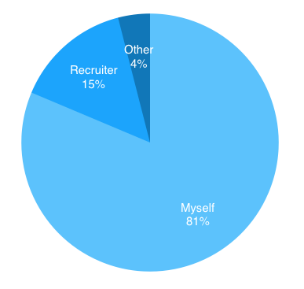

I started applying to positions nearly immediately when redundancy hit which means I might have applied to roles I was not exactly qualified for -- sometimes it was due my own desperation but more often than not the job descriptions were not clear enough. It should come as no surprise at all that only one out of five applications were made through referrals or recruiters who contacted me with roles.

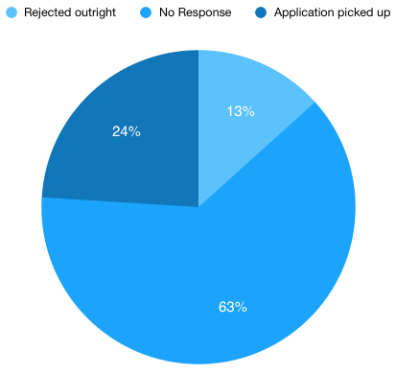

As a consequence of the above and also due to the nature of job hunting, I was only mildly surprised that **nearly two thirds of my applications received no response at all**, while some applications were rejected outright. To be honest, I am quite grateful for these letters of rejection -- at least I, as an applicant, am not held in limbo about the status of my application. Hence, **sending a letter of rejection to candidates is definitely a field where I think companies could do better**. It would take hardly any effort to send a template to applicants stating that they were 'not considered on this occasion'.

So there was no response sent for two thirds of my applications; however, nearly one in four applications did receive a response, and before digging deeper, I really wanted to find out if there is a correlation between the responsiveness of companies and whether the applications were submitted by me, by recruiters on behalf of me or through referrals -- mainly former colleagues or acquaintances whose current companies were hiring Scrum Masters or people in my profession in general.

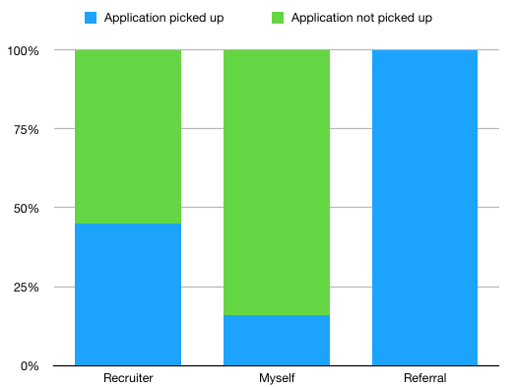

45% of applications made by recruiters were picked up by prospective companies, whilst this rate is merely 16% if you are a random applicant from LinkedIn like me. To put it an other way, **applications through recruiters were three times as likely to raise interest with prospective employers.** Also, all applications that were made through referrals were picked up in my case. Thank you folks, indeed!

Theoretically then, you just need a good network to land on interviews eventually, right? Well, this is not necessarily the case as the next graph will show:

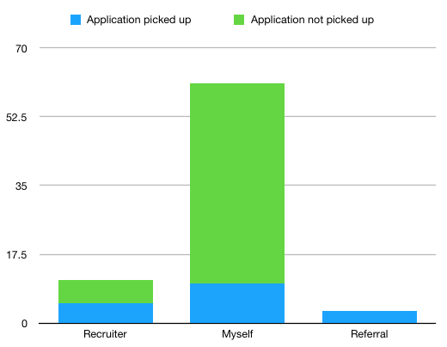

It is true that your network and recruiters representing you have better chances to start your phone ringing, but if you are relentless you will easily outperform them. Looking at the numbers only in this graph, you will see that more of my own applications were picked up than recruiters' and referrals' applications combined.

### It's great to hear from you!

What I was also eager to find out is the response rate in general: how long does it take for companies to come back to us mere mortals:

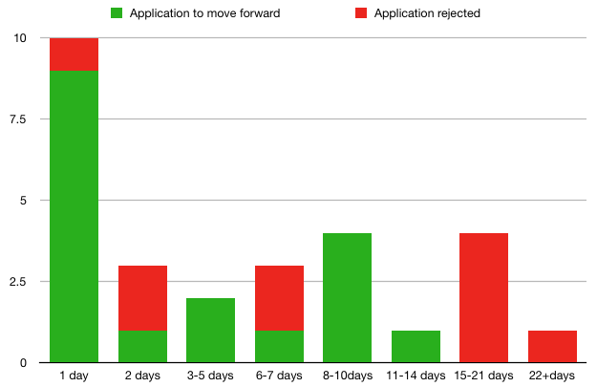

80% of the companies that get back to you, do so within 14 calendar days, and 75% of those wanting to take the process further responded in just seven days. **Half the companies that were definitely interested in me responded the day after my application was submitted.**

### I hope to meet you soon!

Finally, let's see how well those interviews went. For the sake of simplicity, I broke down the interview types as follows:

* Initial interview: The first point of contact with the company -- usually with an internal or external recruiter working for your future employer. You get to know a bit about the role and the company, and then you chat about your CV. Nothing too serious really.
* Phone interview: This is when you get to speak with some like-minded folk, in most cases they are your future colleagues or would-be boss. This is now the real deal, you do get into the nitty-gritty of agile. For us Scrum Masters, the discussion is about your agile experience but it is not uncommon to face situational questions as well in addition to Scrum theory and Agile methodologies in general.
* F2F interview: Finally, you get to meet face to face. This step takes a few hours and you will talk to a wide range of people -- usually in a few rounds. Mostly, these stages are completed on the same day so you speak with a few product owners first then, after a quick break, you continue with some Scrum Masters or Agile Coaches, etc. Depending on the company, you might be invited back one more time to meet a senior manager but in most cases this step is just an additional sanity check -- the decision is likely to have been made by then.

Once you have completed all the interviews, you may or may not get an offer which you may or may not accept. So without any further ado, I present to you...

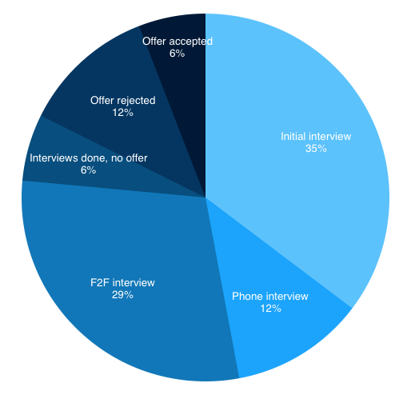

... this chart which shows the stages that I completed during my job hunting journey. Mind you, each stage builds on the previous one, the "Phone Interview" stage means that I have successfully sailed through the initial interviews, and the "F2F Interview" also implies that I have concluded the initial and phone interview stages. I hope this is clear. So let's see the main findings:

I passed two out of three initial interviews which basically means that **once my application was picked up, I was likely to get to the more agile-focused interview steps**, and I was more or less comfortable to whizz through the phone interview stage as well.

**About half the time when a company responded to my application, I was invited into their offices for a face-to-face interview.** Obviously, this is when parties have the opportunity to discover one another. Recruitment should really be a two-way street: it is not only about them finding out if they would want to work with you -- you also need to be positive about wanting to work with them. You need to be enthusiastic about going to work in that office with those people; otherwise, it cannot really be a fruitful and healthy work relationship.

And finally, the good news and a powerful reminder for the future for me is that **about one in five of those casual chit-chats with the lovely HR person over the phone will actually lead to an offer from that company**.

Finding your next role can be a real struggle at times. It is a wild, wild roller coaster with completely unexpected ups and downs and dips and incredibly tight turns. One thing is sure, however: the ride will come to an end eventually, and you will take one of those offers, probably to your own professional benefit as well as to the benefit of the company you will work for.

To conclude, here is what I learned:

* Dear Companies, brush up your hiring processes a bit please. If you have shortlisted 25 candidates you want to move forward with, let the others know that you are not going to consider their applications. It means the world to us. Really. Thanks.
* Recruiters work. Or maybe it was just me that was lucky, but I was three times as likely to receive a positive response to an application when it was submitted by a recruiter. Nevertheless, you must apply relentlessly as well.
* They will reach out soon, if they want to talk to you. This point may be related to the first one. If you don't hear back for two weeks, chances are your application has been binned.
* In my case, half the time my application was picked up, I landed on a face to face interview, and about a third of those interviews ended with me getting an offer in my hand.

I know it is not easy at times but have faith in yourself. If I can do it, anyone can do it.

Good luck!